Creating a full adder in Xilinx FVivado. Here’s a step-by-step tutorial to help you through the process:

Step 1 Create a New Project in Vivado

1. Open Xilinx Vivado.

2. Click on **"Create New Project"**.

3. Name your project (e.g., `FullAdder`), choose a location, and click **Next**.

4. Select **RTL Project** and click **Next**.

5. Click **Add Sources** to add a new Verilog file. Click **Create File**, name it (e.g., `full_adder.v`), and click **OK**.

6. Add Constraints** for now. Click **Next**.

7. Select your FPGA board or the specific FPGA part you're using. Click **Next** and then **Finish**.

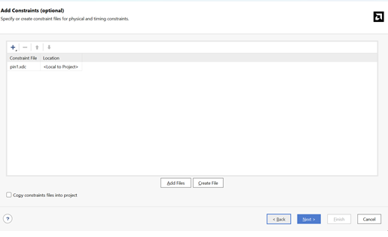 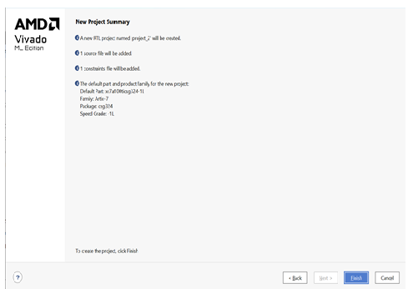

6 7

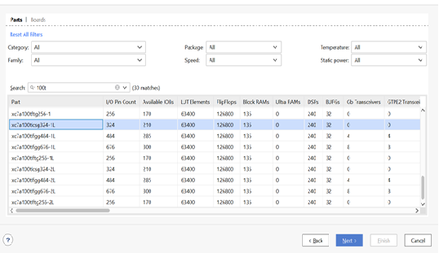

7

Step 3: Write the Verilog Code for the Full Adder

1. In the Sources window, right-click on your Verilog file (`full_adder.v`) and select Open File

2. Enter the following Verilog code for a 1-bit full adder:

```verilog

module full_adder (

input A, // First input

input B, // Second input

input Cin, // Carry input

output Sum, // Sum output

output Cout // Carry output

);

assign Sum = A ^ B ^ Cin; // Sum calculation using XOR gates

assign Cout = (A & B) | (Cin & (A ^ B)); // Carry-out calculation

endmodule

```

### Step 4: Simulate the Full Adder

1. In the Flow Navigator pane, click on **Run Simulationand then Run Behavioral Simulation

2. Create a testbench to verify the functionality of your full adder:

```verilog

module tb_full_adder;

reg A, B, Cin; // Inputs

wire Sum, Cout; // Outputs

// Instantiate the full adder module

full_adder uut (

.A(A),

.B(B),

.Cin(Cin),

.Sum(Sum),

.Cout(Cout)

);

initial begin

// Initialize inputs

A = 0; B = 0; Cin = 0;

#10; A = 0; B = 0; Cin = 1;

#10; A = 0; B = 1; Cin = 0;

#10; A = 0; B = 1; Cin = 1;

#10; A = 1; B = 0; Cin = 0;

#10; A = 1; B = 0; Cin = 1;

#10; A = 1; B = 1; Cin = 0;

#10; A = 1; B = 1; Cin = 1;

#10;

end

endmodule

```

3. Run the simulation and observe the results in the waveform

### Step 5: Synthesize and Implement the Design

1. In the **Flow Navigator**, click on Run Synthesis

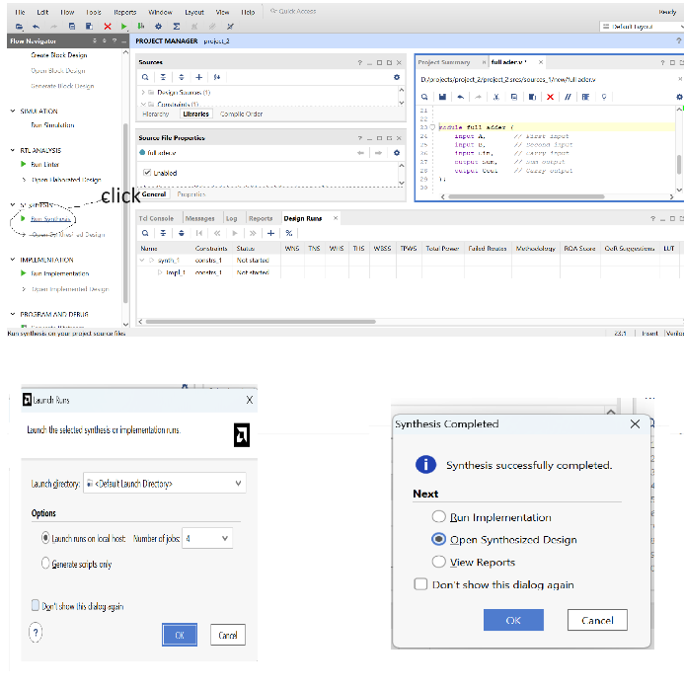

2. After synthesis, click open synthesis design

3 go to latout then IO PLANING SELECT THE PIN AS PER DATASHEET

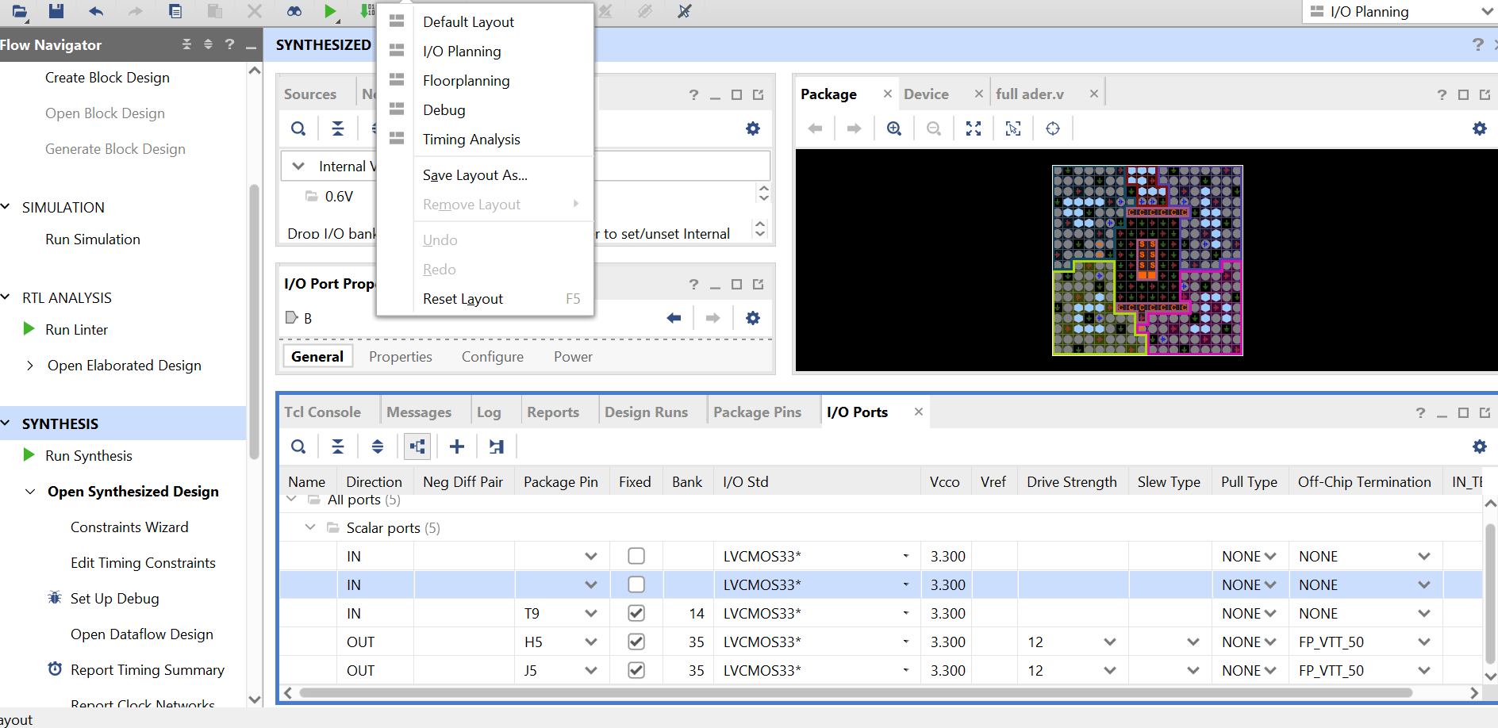

1. After synthesis, click on **Run Implementation

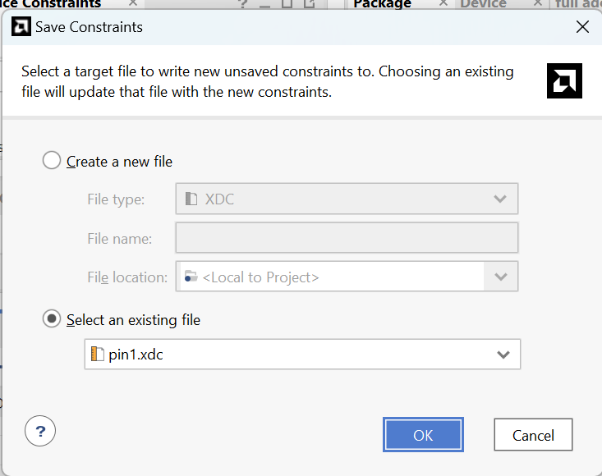 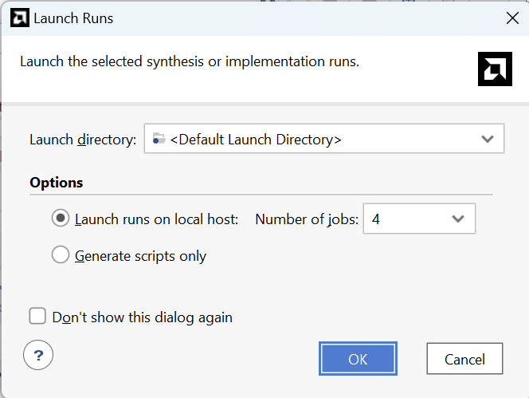

3. Once the implementation is complete, generate the bit stream by clicking on Generate Bit stream**.

Step 6: Program the FPGA

1. Connect your FPGA board to your computer.

2. In Vivado, click on **Open Hardware Manager**.

3. Click on **Open Target** and then **Auto Connect**.

4. Program the device with the generated bitstream file by selecting **Program Device**.